Lab Sheet 4: Simple Servlet

Task 1

package com.example;

import java.io.IOException;

import java.io.PrintWriter;

import javax.servlet.ServletException;

import javax.servlet.annotation.WebServlet;

import javax.servlet.http.HttpServlet;

import javax.servlet.http.HttpServletRequest;

import javax.servlet.http.HttpServletResponse;

@WebServlet("/displayMessage")

public class DisplayMessageServlet extends HttpServlet {

protected void doGet(HttpServletRequest request, HttpServletResponse

response)

throws ServletException, IOException {

response.setContentType("text/html");

PrintWriter out = response.getWriter();

out.println("<html><body>");

out.println("<h1>Welcome to the Java Servlet Lab!</h1>");

out.println("</body></html>");

}

}

<web-app xmlns="http://java.sun.com/xml/ns/javaee"

version="3.0">

<servlet>

<servlet-name>DisplayMessageServlet</servlet-name>

<servlet-class>com.example.DisplayMessageServlet</servlet-class>

</servlet>

<servlet-mapping>

<servlet-name>DisplayMessageServlet</servlet-name>

<url-pattern>/displayMessage</url-pattern>

</servlet-mapping>

</web-app>

# Task 02

# <html>

# <head>

# <title>user Input</title>

# <meta charset="UTF-8">

# <meta name="viewport" content="width=device-width,initial-scale=1.0">

# </head>

# <body bgcolor="gray">

# <div><h1>User Input</h1></div>

# <form action="getUserInput" method="POST">

# <center><table style="width:70%">

# <tr><th><h3>Name</h3></th><th><input type="text" name="unname"></th>

# <tr><td colspan="2" align="center"><input type="submit" value="save"></td></tr>

# </table></center>

# </form>

</body>

</html>

Servlet Code (getUserInput.java):

package com.example;

import java.io.IOException;

import java.io.PrintWriter;

import javax.servlet.ServletException;

import javax.servlet.annotation.WebServlet;

import javax.servlet.http.HttpServlet;

import javax.servlet.http.HttpServletRequest;

import javax.servlet.http.HttpServletResponse;

@WebServlet("/getUserInput")

public class GetUserInputServlet extends HttpServlet {

protected void doPost(HttpServletRequest request, HttpServletResponse

response)

throws ServletException, IOException {

String name = request.getParameter("unname");

response.setContentType("text/html");

PrintWriter out = response.getWriter();

out.println("<html><body>");

out.println("<h1>Input name " + name + "!</h1>");

out.println("</body></html>");

}

}

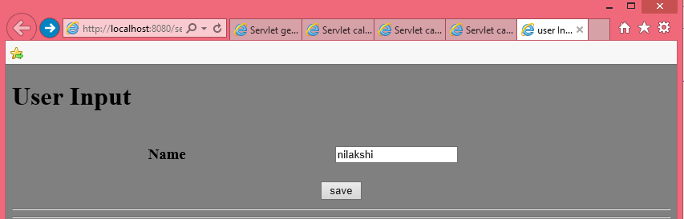

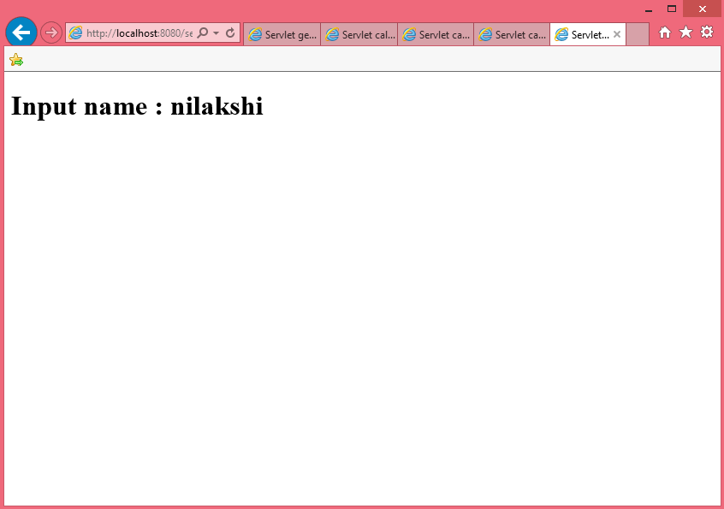

Task 3

# <html>

# <head>

# <title>user Input</title>

# <meta charset="UTF-8">

# <meta name="viewport" content="width=device-width,initial-scale=1.0">

# </head>

# <h1> calculator</h1>

# <form action="calculateSum" method="POST">

# First Number: <input type="number" name="num1" required><br>

# Second Number: <input type="number" name="num2" required><br>

# <input type="submit" value="Calculate Sum">

# </form>

# </body>

# </html>

# import java.io.IOException;

# import java.io.PrintWriter;

# import javax.servlet.ServletException;

# import javax.servlet.annotation.WebServlet;

# import javax.servlet.http.HttpServlet;

# import javax.servlet.http.HttpServletRequest;

# import javax.servlet.http.HttpServletResponse;

# @WebServlet(urlPatterns = {"/calculateSum"})

# public class calculateSum extends HttpServlet {

# * Processes requests for both HTTP <code>GET</code> and <code>POST</code>

# * @param request servlet request

# * @param response servlet response

# * @throws ServletException if a servlet-specific error occurs

# * @throws IOException if an I/O error occurs

# */

# protected void processRequest(HttpServletRequest request, HttpServletResponse response)

# throws ServletException, IOException {

# int num1 = Integer.parseInt(request.getParameter("num1"));

# int num2 = Integer.parseInt(request.getParameter("num2"));

# int sum = num1 + num2;

# response.setContentType("text/html;charset=UTF-8");

# try (PrintWriter out = response.getWriter()) {

# out.println("<!DOCTYPE html>");

# out.println("<html>");

# out.println("<head>");

# out.println("<title>Servlet calculateSum</title>");

# out.println("</head>");

# out.println("<body>");

# out.println("<h1>Calculate Sum</h1>");

# out.println("<h3>First Number : " + num1 + "</h3>");

# out.println("<h3>Second Number :" + num2 + "</h3>");

# out.println("<h1>Answer " + sum + "</h1>");

# out.println("</body>");

# out.println("</html>");}}

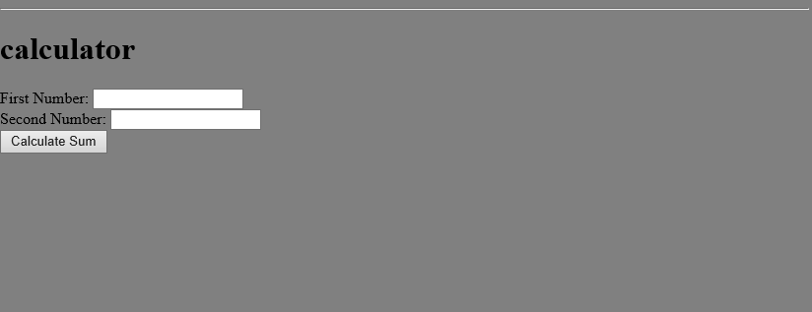

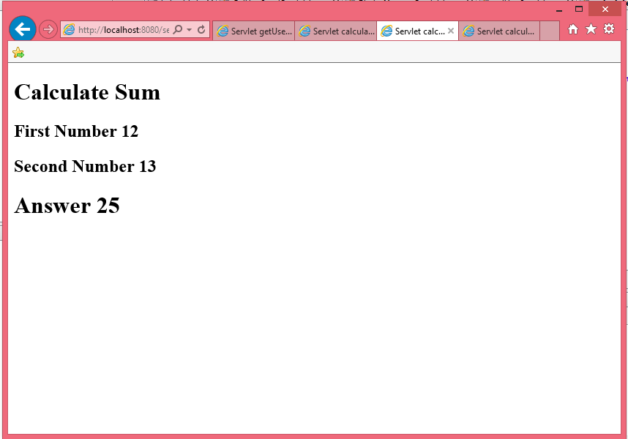  
Task 4: Java Servlet with Database CRUD Operations

**Database Setup**

CREATE DATABASE stock_management;

USE stock_management;

CREATE TABLE stock (

id INT AUTO_INCREMENT PRIMARY KEY,

product_name VARCHAR(255),

quantity INT

);

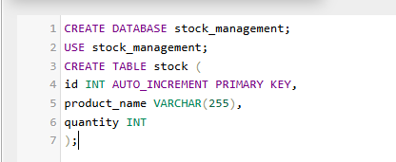

**HTML Form (stockForm.html):**

<!DOCTYPE html>

<html>

<head><title>Stock Management</title></head>

<body>

<h2>Manage Stock</h2>

<form action="stockAction" method="POST">

Product Name: <input type="text" name="product_name" required><br>

Quantity: <input type="number" name="quantity" required><br>

<input type="submit" name="action" value="Add Product">

<input type="submit" name="action" value="Update Product">

<input type="submit" name="action" value="Delete Product">

</form>

</body>

</html>

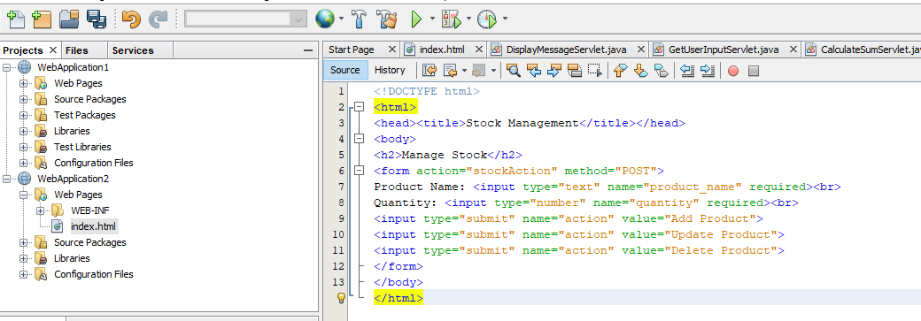

**Servlet Code (StockManagementServlet.java):**

package com.example;

import java.io.IOException;

import java.io.PrintWriter;

import java.sql.*;

import javax.servlet.ServletException;

import javax.servlet.annotation.WebServlet;

import javax.servlet.http.HttpServlet;

SLIATE HNDIT ENTERPRISE ARCHITECTURE 2 YEAR -2 SEMESTR

import javax.servlet.http.HttpServletRequest;

import javax.servlet.http.HttpServletResponse;

@WebServlet("/stockAction")

public class StockManagementServlet extends HttpServlet {

private Connection getConnection() throws SQLException {

String url = "jdbc:mysql://localhost:3306/stock_management";

String username = "root";

String password = "root"; // replace with your database password

return DriverManager.getConnection(url, username, password);

}

protected void doPost(HttpServletRequest request, HttpServletResponse

response)

throws ServletException, IOException {

String action = request.getParameter("action");

String productName = request.getParameter("product_name");

int quantity = Integer.parseInt(request.getParameter("quantity"));

try (Connection conn = getConnection()) {

switch(action) {

case "Add Product":

try (PreparedStatement stmt = conn.prepareStatement(

"INSERT INTO stock (product_name, quantity)

VALUES (?, ?)")) {

stmt.setString(1, productName);

stmt.setInt(2, quantity);

stmt.executeUpdate();

response.getWriter().write("<h1>Product Added

Successfully</h1>");

}

break;

case "Update Product":

try (PreparedStatement stmt = conn.prepareStatement(

"UPDATE stock SET quantity = ? WHERE product_name

= ?")) {

stmt.setInt(1, quantity);

stmt.setString(2, productName);

stmt.executeUpdate();

response.getWriter().write("<h1>Product Updated

Successfully</h1>");

}

break;

case "Delete Product":

try (PreparedStatement stmt = conn.prepareStatement(

"DELETE FROM stock WHERE product_name = ?")) {

stmt.setString(1, productName);

stmt.executeUpdate();

response.getWriter().write("<h1>Product Deleted

Successfully</h1>");

}

break;

default:

response.getWriter().write("<h1>Invalid Action</h1>");

}

} catch (SQLException e) {

e.printStackTrace();

response.getWriter().write("<h1>Database Error: " +

e.getMessage() + "</h1>");

}

}

}

}

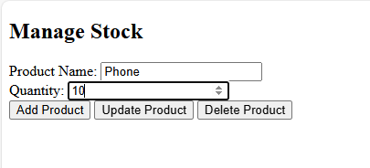

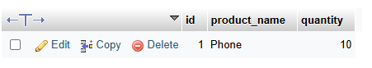

Lab Task 5: Display Data from Database on Another Web Page

**Servlet Code (DisplayProductsServlet.java):**

@WebServlet("/displayProducts")

public class DisplayProductsServlet extends HttpServlet {

protected void doGet(HttpServletRequest request, HttpServletResponse

response)

throws ServletException, IOException {

response.setContentType("text/html");

PrintWriter out = response.getWriter();

try (Connection conn = getConnection()) {

Statement stmt = conn.createStatement();

ResultSet rs = stmt.executeQuery("SELECT * FROM stock");

out.println("<html><body><h1>Stock List</h1>");

while (rs.next()) {

out.println("<p>" + rs.getString("product_name") + ": " +

rs.getInt("quantity") + "</p>");

}

out.println("</body></html>");

} catch (SQLException e) {

e.printStackTrace();

out.println("<h1>Database Error</h1>");

}

}

}